Project Design Phase-II
Solution Requirements (Functional & Non-functional)
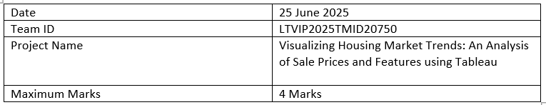
Functional Requirements:
Following are the functional requirements of the proposed solution.
FR No. | Functional Requirement (Epic) | Sub Requirement (Story / Sub-Task)
FR-1 | Data Collection | Upload housing dataset in CSV format
FR-2 | Data Preparation | Clean, filter, and transform data using Tableau Prep
FR-3 | KPI Visualization | Display average sale price, total records, and basement area KPIs
FR-4 | Feature-based Visualization | Visualize house age by renovations, bathrooms, bedrooms, and floors
FR-5 | Dashboard Sharing | Export or share dashboard via Tableau Public link

Non-functional Requirements:
Following are the non-functional requirements of the proposed solution.
FR No. | Non-Functional Requirement | Description
NFR-1 | Usability | Dashboard should be easy to navigate and understand for all user roles
NFR-2 | Security | Only authorized users should upload or modify data
NFR-3 | Reliability | Dashboard should load consistently without failures
NFR-4 | Performance | Load and refresh time should be under 5 seconds for average datasets
NFR-5 | Availability | Dashboard must be available at all working hours without major downtime
NFR-6 | Scalability | Solution must support growing datasets and allow adding new visual modules

